Tuesday, July 12, 2022

3:47 PM

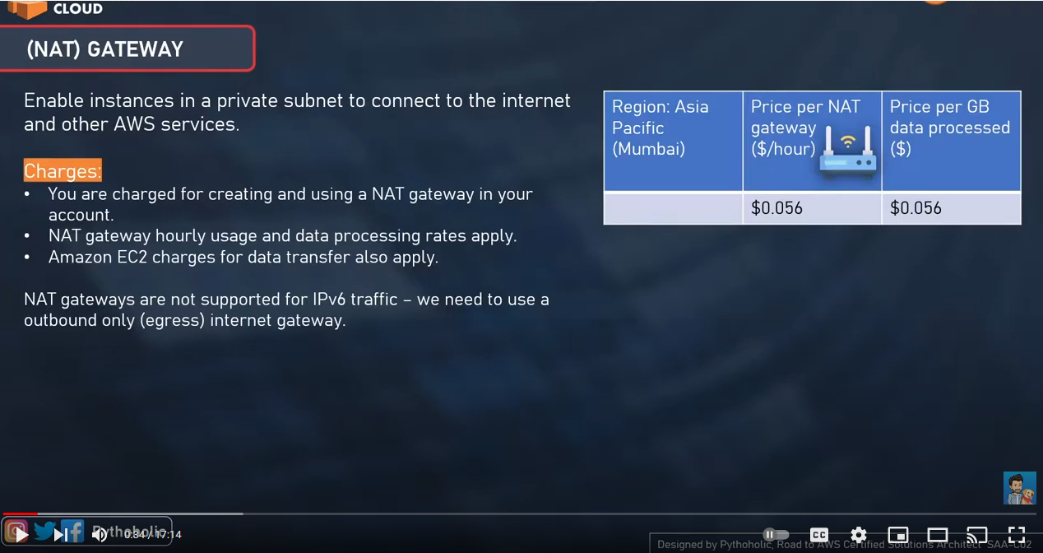

* NAT gateways are not supported for IPV6 traffic

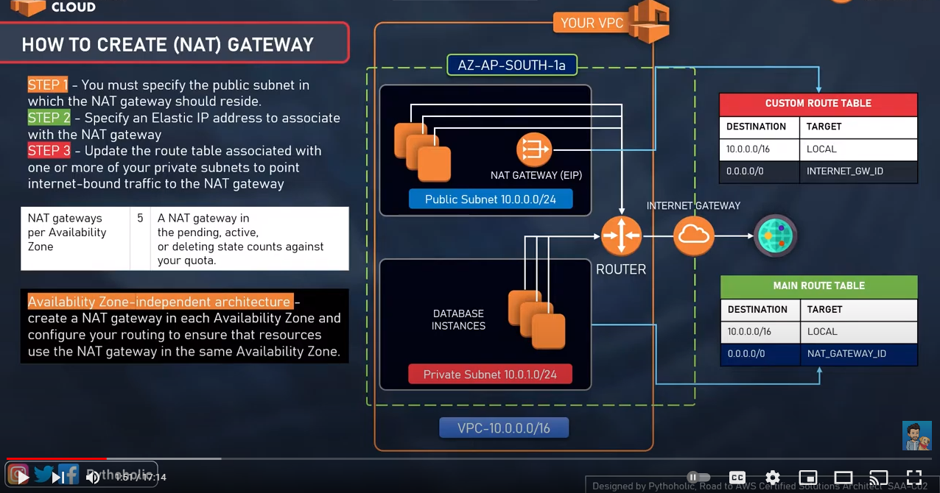

* Max of 5 NAT gateways per availability zones
* Creating a NAT gateway in each AZ avoids any single point of failure.
* The route table for the private subnet sends request to the NAT gateway and the NAT sends it to the internet gateway using the elastic IP which acts as a source IP.